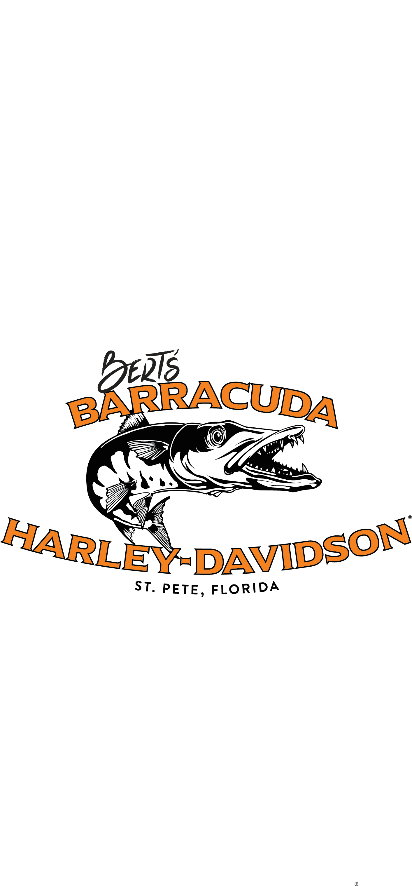
Donation Request Guidelines
Bert’s Barracuda Harley-Davidson is a business committed to the St. Petersburg Community and local causes. We try to participate in as many activities within our community as possible. Due to the large number of requests we receive each month, we ask that you fill out our donation request form.

It is our intent to meet as many donation requests as possible. However, Barracuda Harley-Davidson cannot support all requests for donations as our resources are limited. Below are some guidelines that we take into consideration when reviewing donation requests.
- Organizations which meet local needs and serve people in Pinellas County.
- Motorcycle charity rides.
- Motorcycle-related charities or organizations.
- Organizations which are lead, organized or actively supported by customers of Barracuda.

To have your donation request considered:
- Fill out the donation request form.
- Return the form and supporting documentation to the Barracuda Marketing Coordinator:
Email: bethd@bertsbarracuda.com
Fax: 727.525.0947
Mail/In Person:
Bert’s Barracuda Harley-Davidson
Attn: Marketing
2805 54th Ave. N
Saint Petersburg, FL 33714

- Please submit your request 30 days in advance. Please understand that the more lead time we are given to consider your request, the greater the chance that we can find some way to help you.
- Please provide proof of event in the form of a flyer, poster, ticket or letter from the organization.

ABOUT THE ORGANIZATION
Organization name: __________________________________________________________________________
Is it a 501©3? (Please submit a copy of the tax-exempt certificate) YES NO
Has it received a donation from Bert’s Barracuda in the past YES NO
Organization’s contact person for the donation: ________________________________

Email: __________________________ Phone: ______________________
Relationship to the organization: ____________________________________________
Are you a customer of Bert’s Barracuda Harley-Davidson? YES NO
Organization’s Executive Director: _________________________________________________
Organization’s Board President: ___________________________________________________
Organization’s connection, if any, to the motorcycling community: __________________________________________________________________________

ABOUT THE EVENT
Event Name: __________________________________________________________________________
Benefactor Name: __________________________________________________________________________
Brief description of event. (including event’s goal): ____________________________________________________________________________________________________________________________________________________
Date of Event: ________________________Number of people expected: ____________
Number of years’ event in progress: ______Amount expected to be raised: __________
How will the proceeds be used? ____________________________________________________________________________________________________________________________________________________
Please list event expenses to be covered before any proceeds will be generated for beneficiary: ______________________________________________________________________
Event’s connection, if any, to the motorcycling community: __________________________________________________________________________________________________________________________________________________________________
For individual beneficiaries not affiliated with a charitable organization, what additional aid has been received? (health insurance, government aid, etc.): __________________________________________________________________________________________________________________________________________________________________

ABOUT THE DONATION
Please describe what donation you are requesting: _________________________________________________________________________________
Date Donation is needed by: ______________
Tax ID number, if applicable: ______________
Donation will be used as? (circle) Auction Item Prize Item Other: _____________
If donation is granted, person authorized to pick up donation: ___________________________

BARRACUDA H-D USE ONLY
Date Received: _______________
Request Approved: ____________ Request Respectfully Declined: _____________
Decision made by: ________________________________ Date of Decision: __________________
If Yes, donation of: ________________________________ Total Cost: _______________________
Donation picked up by: _____________________________ Date: ___________________________

